Ruff Update - January - March 2024

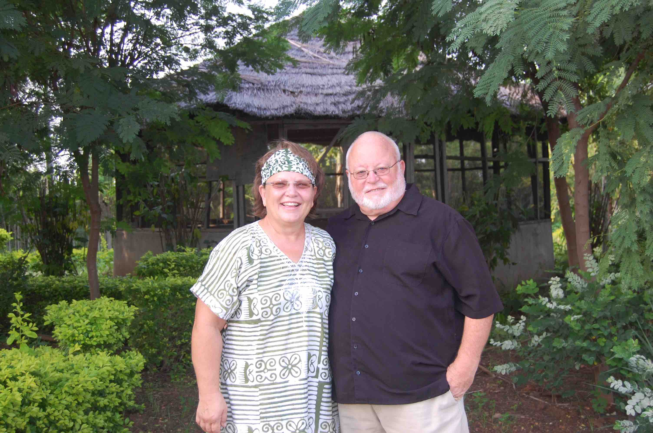
Greetings from the Ruffs!
Here are some highlights of the first three months of 2024
- This season of ministry we are focusing on connecting Isaac with other Africans to collaborate how they can set the continent ablaze with the gospel. It has been 2000+ years since Jesus commanded his followers to disciple the nations and still "a third of us," 1/3 of the world's population hasn't even heard, let alone been discipled. This is why Amy and I are Zume coaches, helping Africans be catalysts for Disciple Making Movements (DMMs). That is why Amy is a Fidelis Project cohort leader for four African groups. Now some of the Fidelis students who have graduated with their Master's of Arts in Catalytic Leadership, are now beginning to be Cohort leaders for other who want to earn the Master's degree as well.
- Isaac took a Ghanaian team of people to help with a Teach To Transform medical training for 50 DMM workers in Sierra Leone. So key DMM leaders in Ghana, Nigeria and Sierra Leone now have basic medical skills that they can offer in the remote areas where they go to make disciples. This training has opened up many doors for them. Thank you to good friends of ours from Northside, Stuart and Janet Eldridge, who have helped with all three trainings.
- Isaac was invited to the global 2414 meeting in Nairobi, Kenya. The name is derived from Matthew 24:14 and people from all over the globe met to evaluate how we are doing and strategizing how to finish the task. It was a real encouragement for Isaac to learn from DMM catalysts like Curtis Sergeant, Neil Cole, Cynthia Anderson, Lee Wood, Aila Tasse and Kenny Fong, to name just a few.
- For the last three years Isaac has attended the Global DMM Catalyst Camp held in Nairobi, Kenya where African DMM catalysts assemble to collaborate and strategize about DMMs. This year, Isaac has been asked to bring key DMM leaders with him from West Africa to share at the catalyst camp. We are busy at work arranging the details that will allow this to happen. Please pray with us. The date for the catalyst camp is June 11-14 2024.
- The veterinarian I mentioned in last month's report did his first online training of Isaac and Bobby and Mandy on how to care for goats. We hope this training can be replicated for key farmers throughout the DMM networks in the countries, so we are in to help provide sustainable food and income for the DMMers. He is working on a training on how to care for sheep soon. These are done in such a way that those who take the training will be given 5 goats with promise for them to pay it forward to someone else. I like it. Not only are we multiplying disciples, but we are also multiplying animals.
- We are still meeting with a lot of DMM people in California where we live to see what we can do to multiply simple obedience-based discipleship groups (churches). Recently we have been going through Francis Chan's training and this coming Sunday we will attend Steve Addison's new book tour where we will hopefully meet more DMM minded people in the bay area.
- Of course, we are enjoying our two grandchildren. Hattie is two years old now. She loves her grandma and new baby brother Rye. Grandma of course loves holding Rye. You got admit he is a pretty baby boy.
- Terry's physcial therapy treatments will wrap up the first of May. He is walking with a cane now. Amy just had carpel tunnel surgery and is recuperating from that. Prayers are appreciated.
Thank you all so much for making this happen. We couldn’t do it without your partnership
May God be glorified!
Terry and Amy Ruff
P.S. As usual if you want to contact us please email us at: truff@mynorthside.com or aruff@mynorthside.com

